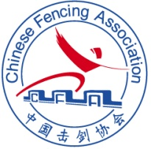
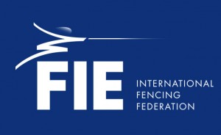

2023 FIE Women’s Epee World Cup (Nanjing)
24-26 March, 2023

Dear Friends,

It is with great pleasure that, on behalf of the Chinese Fencing Association, I invite you to the FIE Women’s Epee World Cup which will be held in Nanjing city, Jiangsu Province on March 24-26, 2023.

Details of the competition are as follows:

Organizers
Chinese Fencing Association
Address: No.5, Laoshan West Street, Shijingshan District, Beijing 100049, China.
Telephone: +86 10 68862588
Email: fencing@sports.cn

Competition Venue
YANGZI RIVER INTERNATIONAL CONFERENCE CENTER
Location:
299 Binjiang Avenue, Jiangbei New Area,Nanjing,Jiangsu,China.

Schedule of the Competition (to be comfirmed)

Thursday 23st Mar.
- [08h30-11h30] :weapon control (Venue)
- [13h30-16h30] :weapon control (Venue)
- [08h30-16h30] :entry fee acceptance (Venue)

First Day - Friday 24nd Mar. -Individual:
- [08h00] :weapon control & entry fee acceptance(Venue)
- [09h00] beginning of round of pools
- followed by: preliminary table of 128

Second Day - Saturday 25th Mar. -Individual:
- [08h00] :weapon control
-[09h00 ]: table of 64
-[18h00]: Final

Third Day - Sunday 26th Mar. -Team:
- [08h00] :weapon control
-[09h00 ]: table of 32
-[16h00]: Bronze Medal Match
- [17h00]: Final

Participation

Alt 1. For Individual World Cup competitions, each national federation may enter a maximum of 12 fencers. The organising country may enter up to 20 fencers plus the number needed to make up the pools.

Alt 2. For Individual World Cup competitions outside Europe, the organising country may enter up to 30 fencers plus the number needed to make up the pools.

Team participation is open to all countries and limited to one team per weapon per country.

Entry

Every competitor is required to be licensed for the 2022-2023 season.
No fencer is allowed to take part in an official event of the FIE unless he or she is at least 13 years old on 1 January in the year of the competition.
Entries of fencers, teams and referees can only be made at the FIE website, www.fie.org, respecting the deadlines specified in the FIE Rules (cf. o.54).

Entry Fee

Individual competition: EUR 60. Team competition: EUR 400.
The entry fee is paid for each national delegation by bank transfer to:
125911150210902 no later than 13th Mar. 2023.
Please kindly send the copy of transfer voucher, team and name list to:
fencinginnanjing@163.com

Account Information：
Name of the account: Nanjing Jiana Sports Culture Development Co. Ltd
Account No.: 125911150210902
Bank Name: CHINA MERCHANTS BANK H.O. SHENZHEN
Swift Code: CMBCCNBSXXX
Address: 201, Building 1, Creative East 8th District, No. 1, Guanghua East Street, Qinhuai District, Nanjing, Jiangsu, China
The entry fee can also be paid at registration before the start of the competition.

Referee Obligation

The referees are designated by the FIE and delegations will not have to provide any referees.

Formula

Individual competitions – One qualifying round of pools, a preliminary direct elimination table, a main direct elimination table of 64 fencers to qualify for a final by direct elimination.
Team competitions – Integral direct elimination with a direct elimination table which may be incomplete. All places in the table up to 16th place will be fought for. From 17th place onwards teams will be classified, within each round of the table, according to their initial place in the table. The first four teams will be placed in the direct elimination table according to the current official team ranking of the FIE (cf. o.86); the remaining ranked teams will be placed in the table by drawing of lots in pairs. The teams that are not classified will occupy the last places in the table, and will be separated by drawing of lots (cf. o.42-o.47).

Doping Control
Doping control will be done according to FIE rules.

Accommodation and Transport

Please Kindly contact fencinginnanjing@163.com no later than 13th Mar. 2023, if you wish to avail of the special hotel rates provided by the Organizers.
Hotel | Price | Address
1.YANGZI RIVER INTERNTIONAL CONFERENCE CENTER Hotel  2.HUALUXE Nanjing Yangtze River Hotel  3.EVEN Hotel Nanjing Yangtze River Hotel | 1.Double(2 beds) 116EUR/night/room  Single(1 bed)： 116EUR/night/room  2.Double(2 beds) 78EUR/night/room  Single(1 bed)： 78EUR/night/room  3.Double(2 beds) 62EUR/night/room  Single(1 bed)： 62EUR/night/room | - 299 Binjiang Avenue, Jiangbei New Area,Nanjing  - No.504,Binjiang Avenue, Jiangbei NewArea,Nanjing,Jiangsu  - No.504,Binjiang Avenue, Jiangbei NewArea,Nanjing,Jiangsu
Note:
1. All the above rates are inclusive of room, breakfast in the hotel and does not include other personnel room services.
2. Check-out time: before 12:00 pm. Check-out from 12:00 pm to 17:30 pm--charge for another half day rate.
3.Hotel and transport charges will have to be paid to the organizer before 13th Mar. 2023 or upon confirmation of booking.
4.Please take note that the competition date coincides with a major convention fair hence hotel accommodation is scarce and rate is higher than norm. It is advisable to book earlier if you do not wish to use the hotel designated by the organizer.
5. Please kindly send the copy of transfer voucher, team and name list to:
fencinginnanjing@163.com
If you need airport pick-up service, please send your flight information to the organizing committee. The transportation between Nanjing Lukou International Airport and official hotels will be provided at following price: 33EUR/person/round trip. Free transportation will be provided between official hotels and competition venue on competition days.

Visa Support

Please Kindly check for visa requirements to CHINA before making your ticket reservations. Those who need visa assistance and/or visa support, please provide the copy of your passport together with the visa application form and send to contact fencinginnanjing@163.com no later than 3st Mar. 2023.

Insurance
Each team must assume all responsibilities for accident and health insurance as well as the civil liabilities for their competitors and officials during the event.

COVID-19 INFORMATION

Travelers to China are required to take a nucleic acid (PCR) test 48 hours before departure and those with negative results can enter China.

Covid-19 plan for the 2022-2023 season,the sanitary measures at FIE competitions have been adapted as follows, until further notice:
- Wearing a sanitary mask is no longer compulsory, but remains recommended;
- Participants will have to present to the organisers the negative result of a Covid-19 test (PCR or rapid antigen test), carried out within a maximum of 72 hours before arrival in the country.

Other sanitary measures at the competition may be implemented by the host federation at their option or as required by the national authorities.

However, in case the Covid-19 situation would worsen, the sanitary measures will be revised accordingly, and federations will be informed immediately.

Further Information and Contact Person

Organizer: Chinese Fencing Association
Address: No.5, Laoshan West Street, Shijingshan District, Beijing100049, China.
Email: fencing@sports.cn /event.fe@sports.cn Telephone: +86 10 68862588

Organizing Committee: Nanjing Jiana Sports Culture Development Co. Ltd
Address:201, Building 1, Creative East 8th District, No. 1, Guanghua East Street, Qinhuai District, Nanjing, Jiangsu, China
Contact person: Liang yang
Mobile phone: +8618168411441
Email:fencinginnanjing@163.com

Wang Haibin
President
Chinese Fencing Association

YANGZI RIVER INTERNTIONAL CONFERENCE CENTER HOTEL
Location: 299 Binjiang Avenue, Jiangbei New Area,Nanjing

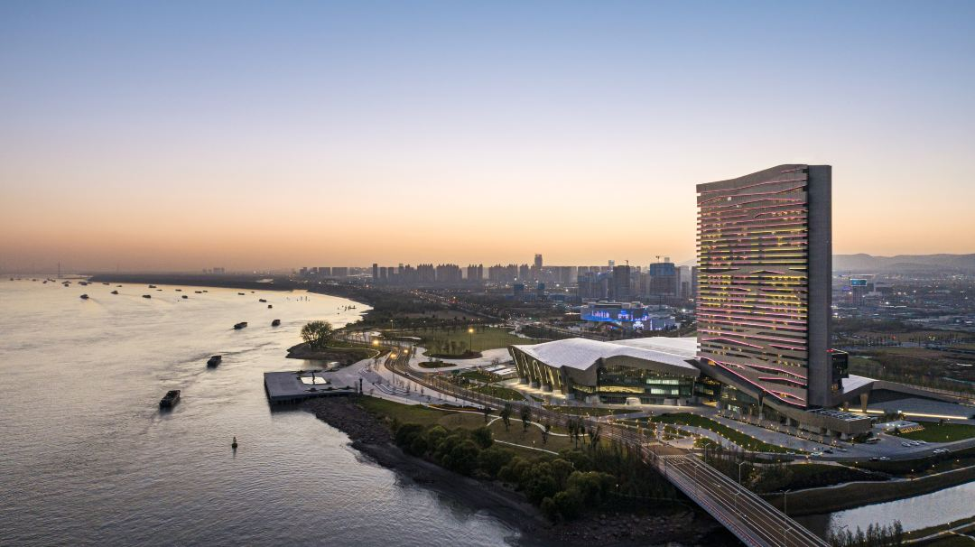

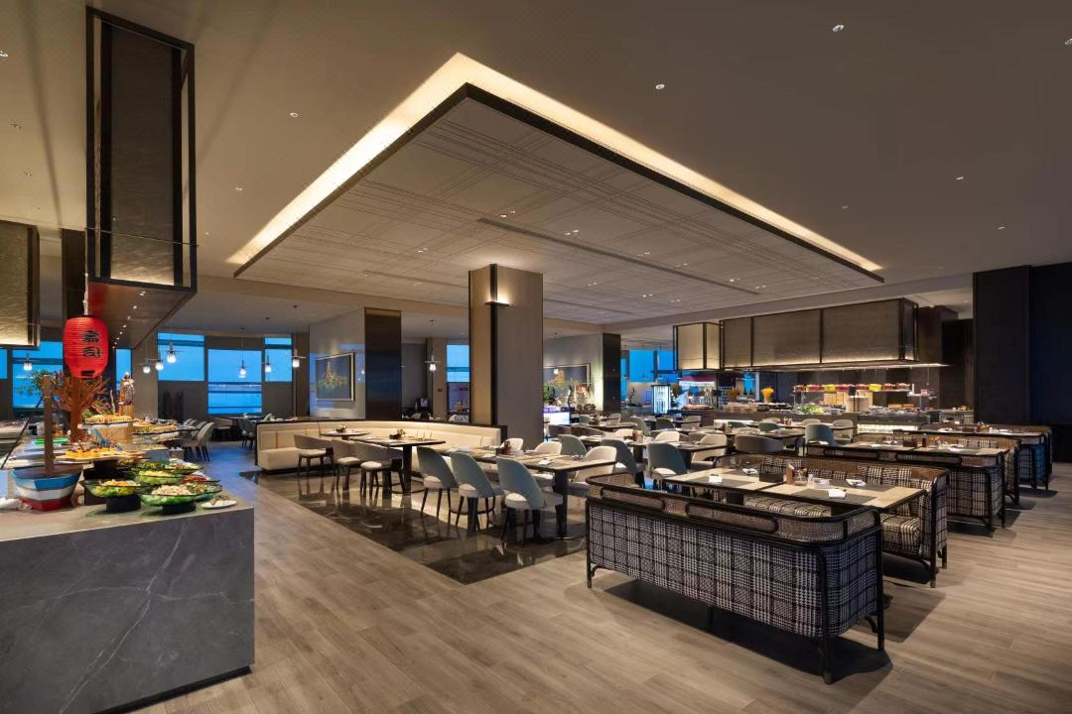

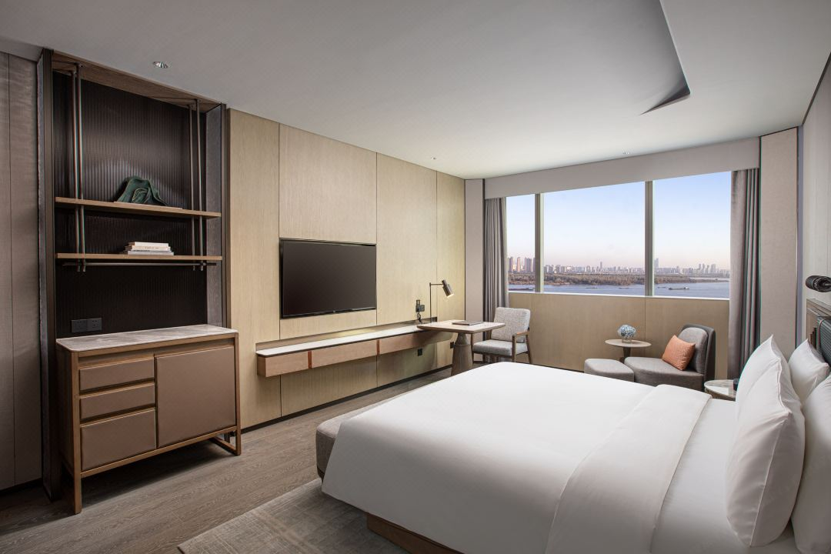

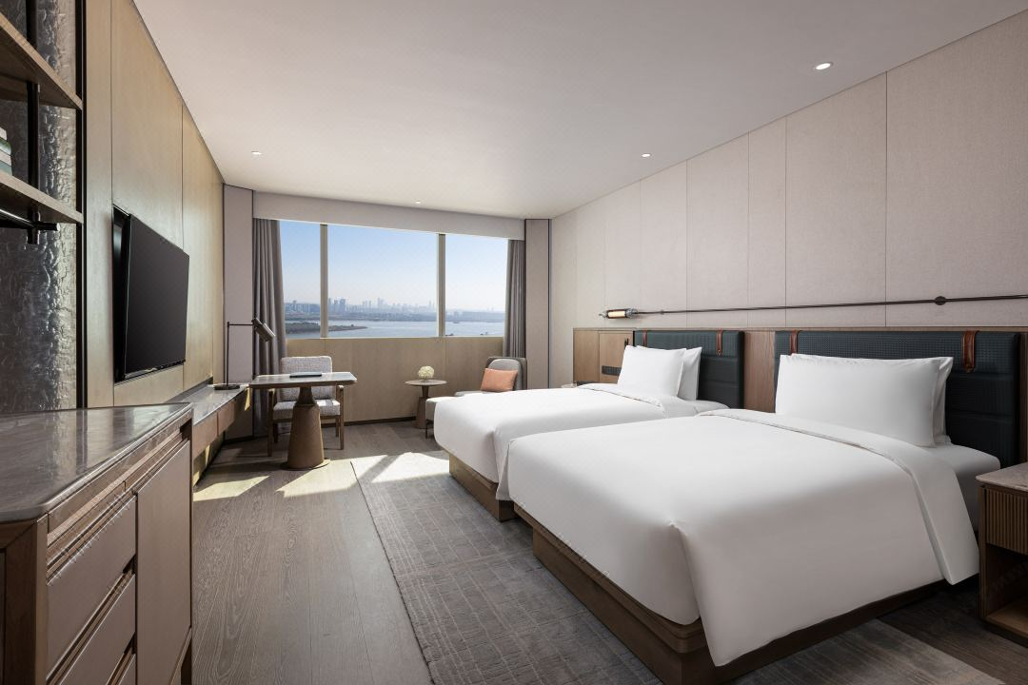

HUALUXE Nanjing Yangtze River Hotel
Location: No.504,BinjiangAvenue,JiangbeiNewArea,Nanjing,Jiangsu

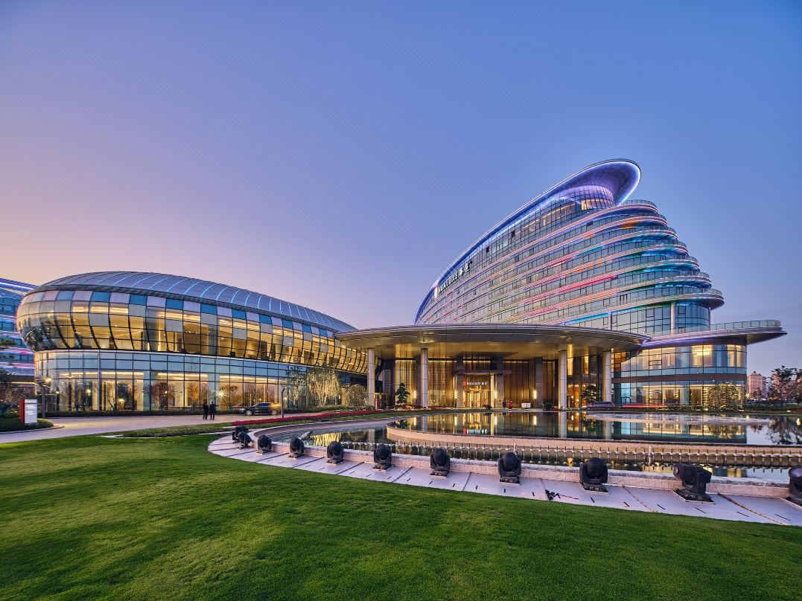

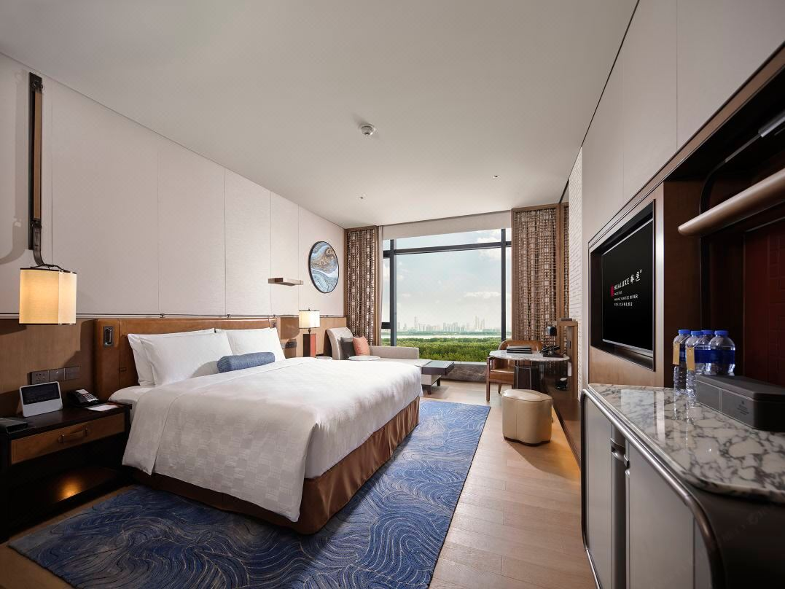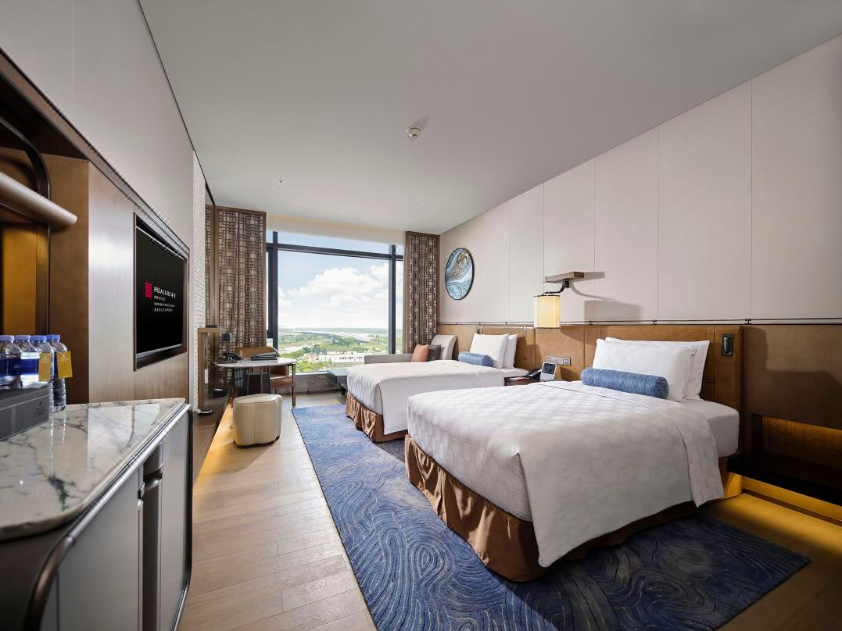

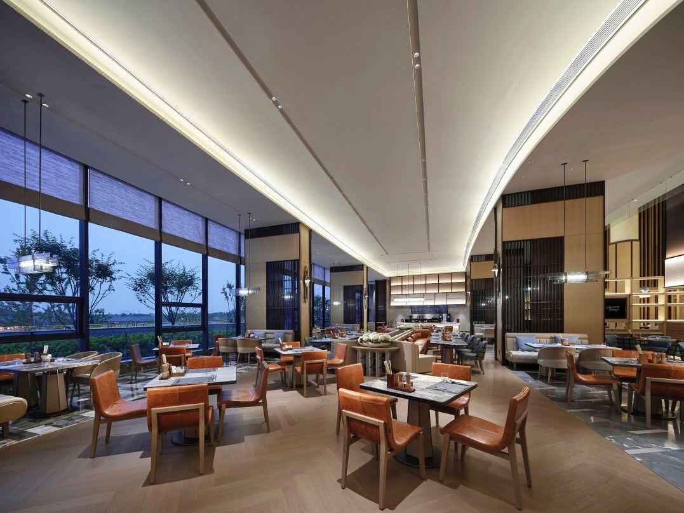

EVEN Hotel Nanjing Yangtze River Hotel
Location:No.504,Binjiang Avenue, Jiangbei NewArea,Nanjing,Jiangsu

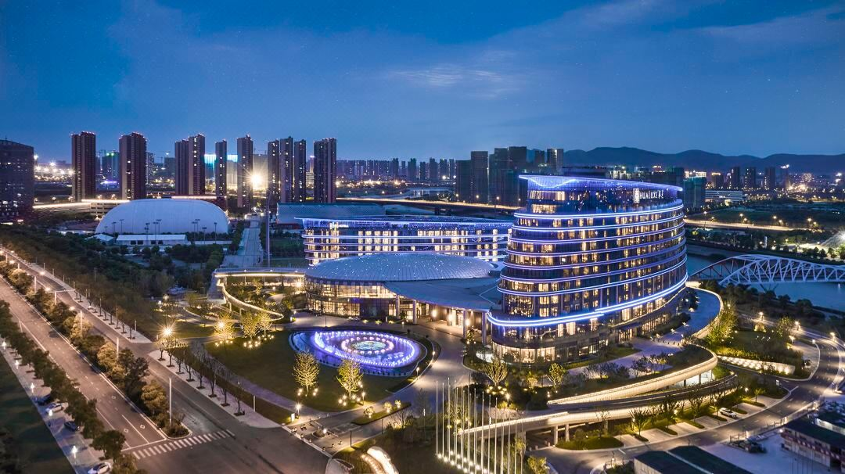

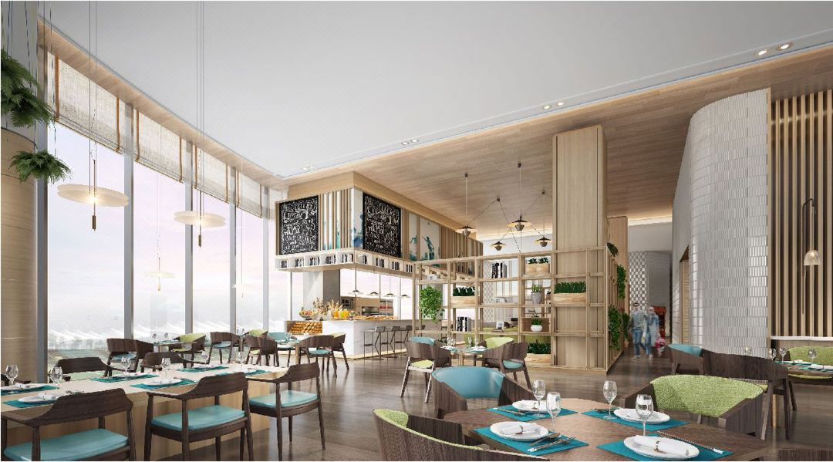

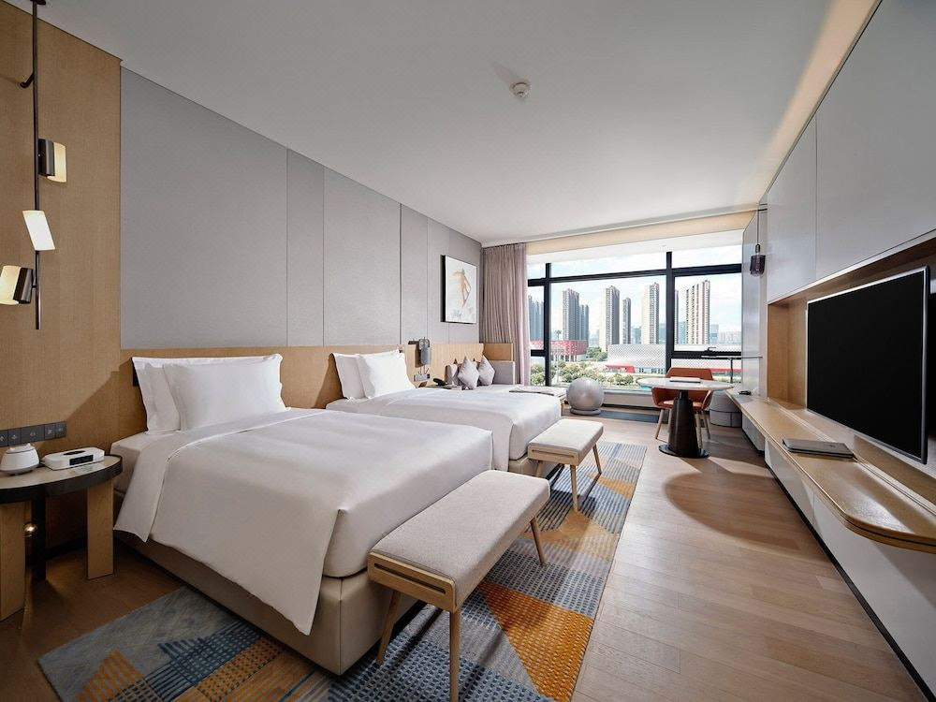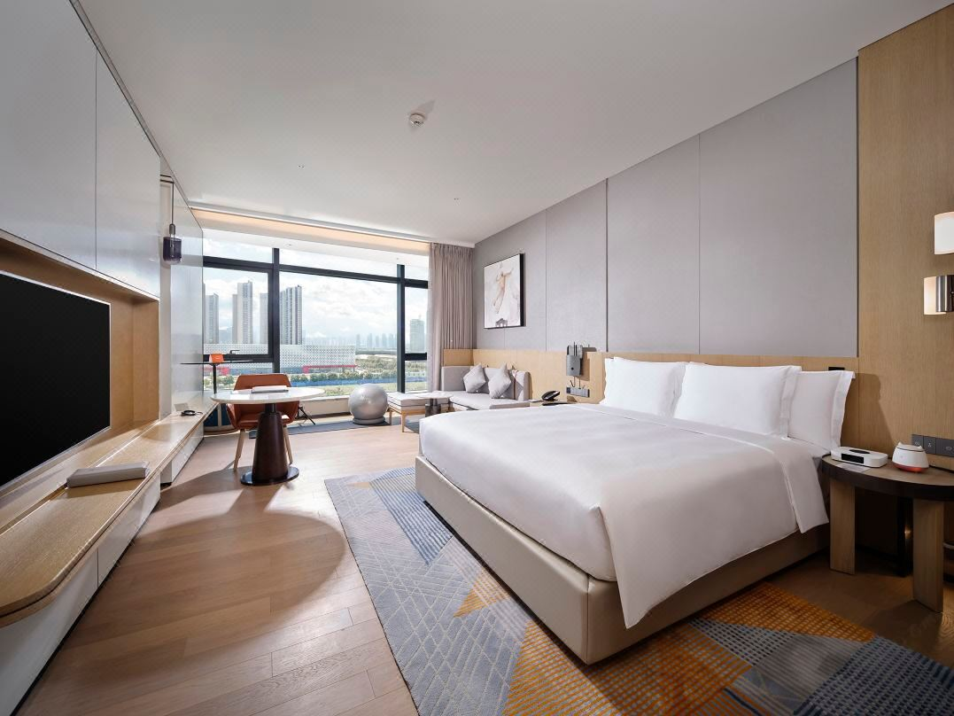

Distance Map：
Nanjing Lukou International Airport——Official Designated Hotel
57 kilometres/ 50 minutes 'drive
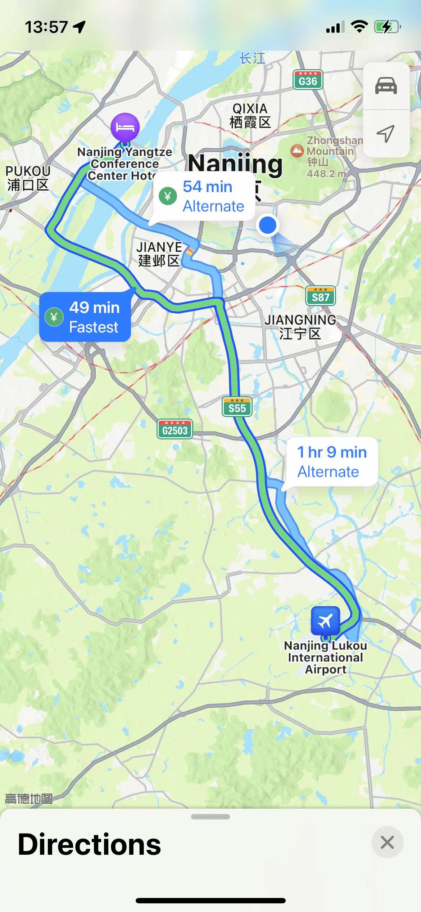

Official Designated Hotel —— Competition Venue
YANGZI RIVER INTERNTIONAL CONFERENCE CENTER HOTEL :
200 metres/3 minutes 'walk
HUALUXE Nanjing Yangtze River Hotel/EVEN Hotel Nanjing Yangtze River Hotel:
7.4 kilometres/ 11 minutes 'drive
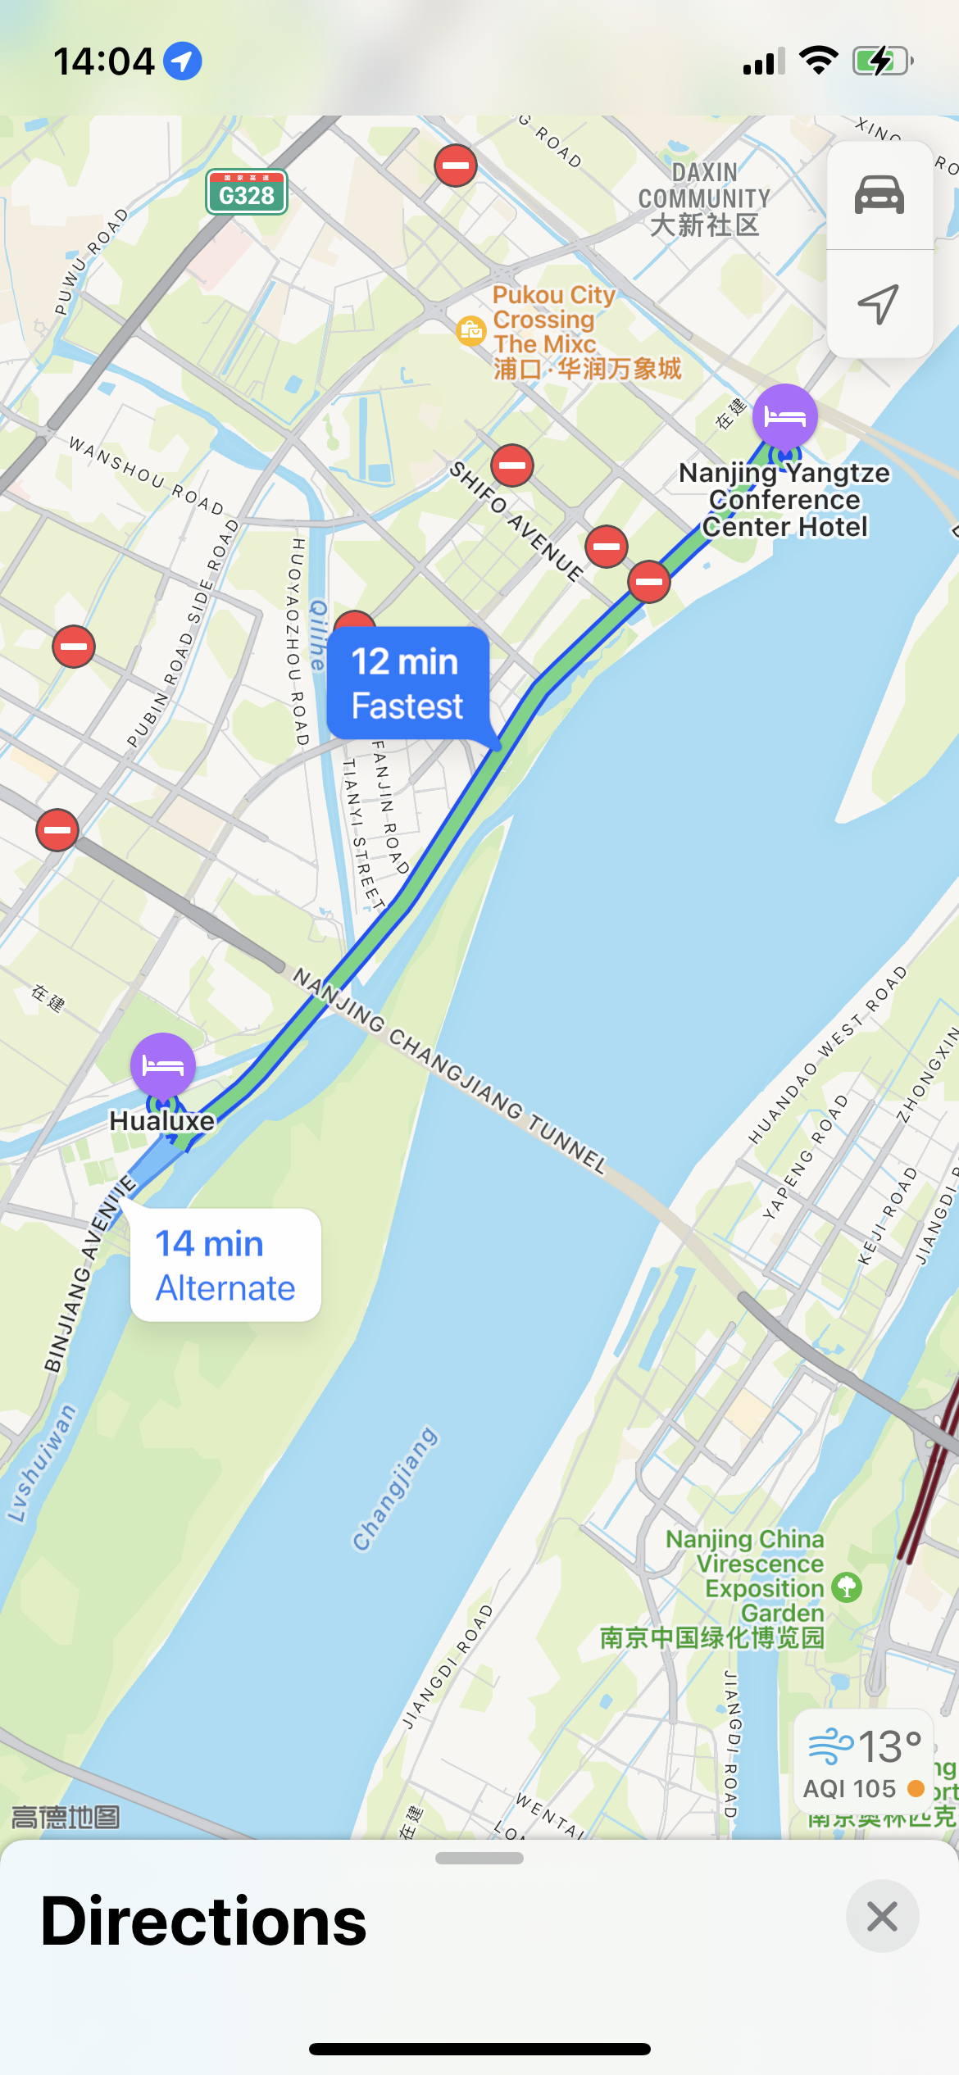

visa application form

被邀请人员名单汇总审核表 NAMELIST OF THE INVITED
序号NO. | 姓 SURNAME | 名 GIVEN NAME | 性别 SEX | 出生日期YY/MM/DD | 国籍 NATIONALITY | 护照号码 PASSPORT NO. | 职业/队内职务 PROFESSION/POSITION | 签证申请国家 APPLYING COUNTRY | 签证申请城市APPLYING CITY | 入境日期 DATE OF ENTRY
1
2
3
4
5

*Please provide the copy of your passport together with this form.
Please fill the full name as the first page of your passport.

