**Nordic Fencing Festival**

**Nordic Fencing Championships 2025**

**Danish Fencing Federation proudly invites you to the Nordic Fencing Festival from *28th to 31st of august 2025*.   
Our goal is to build a bridge of friendship between fencers, and we look forward to welcoming you and your families in *Copenhagen*.**

**Venue: Taastrup Idræts Center (TIC)**

**Parkvej 78, 2630 Taastrup, Denmark**

Nordic fencing championships is open to all fencers all over the world. The festival will feature competitions in the following categories: U13, U15, U17, U20, U23, Senior, and Veterans. More information will follow, including an exciting program with activities beyond the action-packed fencing schedule—featuring the thrilling **Saturday Super Finals**.

**Thursday 28.08**

U20 epee women and men

U20 foil women and men

U20 saber women and men

Veteran epee women and men

Veteran foil women and men

Veteran saber women and men

**Friday 29.08**

U17 epee girls and boys

U17 foil girls and boys

U17 saber girls and boys

U20 epee women and men team

U20 foil women and men team

U20 saber women and men team

**Saturday 30.08**

U15 epee girls and boys

U15 foil girls and boys

U15 saber girls and boys

Senior epee women and men

Senior foil women and men

Senior saber women and men

**Sunday 31.08**

U23 epee women and men

U23 foil women and men

U23 saber women and men

U13 epee women and men

U13 foil women and men

U13 saber women and men

Senior epee women and men team

Senior foil women and men team

Senior saber women and men team

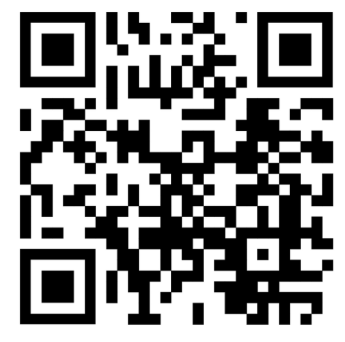

**Registration** for the Nordic Fencing Festival is available through Ophardt: <https://www.fencingworldwide.com/en/32388-2025/tournament/>   
If you do not have access to Ophardt, you may register your team by email: emilia.borrye@faegtning.dk

Individual registrations can be completed using the QR code